Checkpoint 1
Course: AIN4312 — Special Topics in Artificial Intelligence II
Project Title: AI-Based Smart Energy Management and Web-Controlled Simulation System

ABSTRACT
This project aims to develop a fully web-based intelligent energy management system that simulates, analyzes, and optimizes energy consumption in smart buildings using artificial intelligence. The platform will act as a digital twin, virtually replicating sensors, devices, and energy data to allow users to monitor and control operations entirely online. A Deep Q-Network (DQN) reinforcement learning model will be used to learn adaptive control strategies that balance comfort and energy efficiency. A dynamic calibration module will be designed to estimate energy behavior for each virtual device, and a gradual control mechanism will be applied to ensure smooth changes throughout the day. A real-time alert system will also be implemented to detect any abnormal increases in energy usage. The ultimate goal is to create an interactive simulation framework that will later be deployable in real-world systems.

1. OVERVIEW

1.1 Need Identification
Traditional energy management systems rely on static or manual control mechanisms that lack adaptive intelligence, often leading to inefficiency and wasted energy. This project proposes a scalable web-based simulation environment that enables dynamic testing of AI-based energy management algorithms without requiring physical hardware. It will serve as a testing ground for intelligent decision-making systems capable of optimizing energy use dynamically.

1.2 Problem Definition
Current smart home systems automate operations but lack the ability to predict or adapt to future consumption patterns. They depend heavily on pre-set schedules and user inputs. Our system addresses this gap by integrating reinforcement learning, allowing the agent to learn optimal energy-saving actions while maintaining comfort levels. Each virtual device will have unique power profiles, enabling the RL agent to generalize and adapt its behavior across multiple simulated conditions.

1.2.1 Functional Requirements
- Develop a web dashboard that displays all devices, rooms, and total energy consumption in real time.
- Generate virtual environmental data (indoor/outdoor temperature, humidity, and energy demand) with realistic calibration.
- Design and train a DQN agent capable of making hourly control decisions.
- Implement a central calibration file to define baseline consumption and comfort thresholds for each device.
- Build a gradual control mechanism to ensure progressive environmental adjustments.
- Integrate a real-time alert system that triggers warnings when consumption or temperature exceeds safe limits.

1.2.2 Performance Requirements
- RL training over 50 episodes (simulated 50 days) to reach stable convergence.
- Target predictive accuracy R² ≥ 0.85.
- Decision response time ≤ 1 second.
- Achieve ≥ 20% reduction in total energy use compared to random control.
- System uptime ≥ 99% during simulation.

1.3 Proposed Solutions
The proposed system integrates multiple components working in harmony. The SmartHomeEnv class will emulate energy flow and thermal dynamics. Each simulation step will calculate energy consumption, temperature deviation, and comfort level. The ImpactCalibrator module will automatically map control actions (e.g., “turn_on,” “eco_mode,” “set_high”) to energy and temperature impact coefficients. The RLAgent, built with PyTorch, will utilize the DQN model to learn optimal energy-saving policies through trial and error.
The system will operate as a closed feedback loop consisting of sensing, decision-making, and execution. The web interface will display real-time analytics, system logs, and energy performance indicators. While the system will initially run in a simulated environment, it will feature an API-ready structure for future integration with real IoT devices.

1.4 Literature Review
Recent research highlights the effectiveness of reinforcement learning in energy optimization. Studies published by IEEE (2023) demonstrated up to 25% reduction in HVAC energy use using DQN. Similarly, Elsevier (2024) research proved that reinforcement-based energy controllers maintain stable indoor temperatures under dynamic conditions. Notably, Google DeepMind’s data center optimization and MIT’s smart energy lab validated the role of AI in autonomous energy decision-making. These findings underpin the motivation to combine DQN learning with virtual simulation for intelligent, risk-free energy management.

1.5 System Architecture
The system is composed of six interdependent layers: 1. Virtual Sensors Layer: Generates synthetic environmental data (temperature, humidity, energy load).
2. Device Management Layer: Defines devices, energy parameters, and operational permissions.
3. Environment Simulation Layer (SmartHomeEnv): Models energy and temperature transitions.
4. AI Layer (RLAgent): Employs DQN-based learning for optimal energy decisions.
5. Calibration Layer (ImpactCalibrator): Auto-generates energy-temperature mapping rules.
6. User Interface Layer (Web Dashboard): Displays real-time metrics, alerts, and analytics.

2. WORK PLAN

2.1 Work Breakdown Structure (WBS)
Phase | Duration | Tasks
Phase 1 | Weeks 1–3 | Build simulation environment, device catalog, and calibration module
Phase 2 | Weeks 4–6 | Implement DQN and integrate RL with virtual environment
Phase 3 | Weeks 7–9 | Train RL model, tune reward functions, and analyze learning curves
Phase 4 | Weeks 10–11 | Develop full web interface and connect to live data feed
Phase 5 | Weeks 12–13 | Add alert engine and KPI monitoring dashboard
Phase 6 | Week 14 | Final testing, error correction, and report submission

2.2 Team Responsibilities
- Project Manager: Oversees all phases and ensures full system integration.
- AI Engineer: Designs and trains the DQN model and optimizes performance.
- Web Developer: Builds the front-end dashboard and back-end FastAPI integration.
- Data Engineer: Develops calibration logic and synthetic data generation.
- Tester/QA: Performs validation, stability, and system verification.

APPENDIX A

Simulation and Data References
Source | Description
Device Catalog | JSON file listing devices, base power (kWh), and available permissions
Impact Map | Auto-generated file mapping keywords to energy/temperature coefficients
Home Configuration | JSON file defining virtual rooms, devices, and comfort ranges
Training Logs | Contains RL states, actions, rewards, and performance KPIs

System Workflow
- Virtual sensors continuously generate simulated data.
- SmartHomeEnv processes data and defines the current state.
- The RLAgent analyzes the state and selects the optimal action.
- The environment updates energy and temperature accordingly.
- The dashboard visualizes performance, decisions, and alerts in real time.

Model Evaluation Results
The system was tested to verify the prediction accuracy of the learning models.
The following figure (Figure 4) presents the comparison between actual and predicted results for two parameters: - Room Temperature — The predicted values follow real dynamics with minimal deviation. - Synthetic Energy — The predicted energy usage aligns closely with actual consumption patterns.
Figure 4 — Model Prediction Accuracy (Actual vs Predicted)
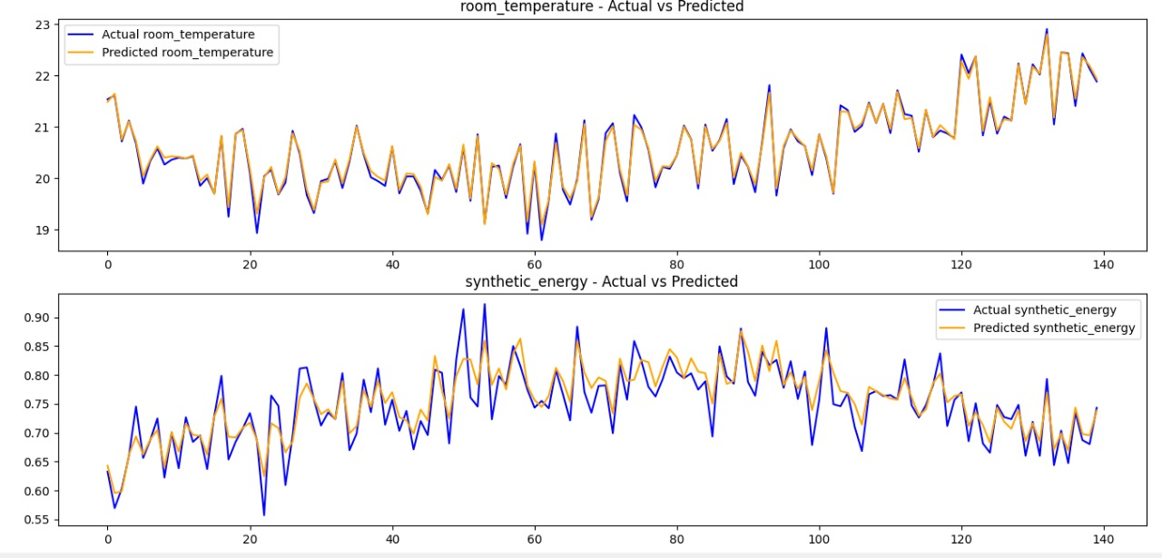
(Room temperature and energy consumption trends across 150 simulated steps)
This confirms that the trained model achieved accurate parallelism between predicted and actual values, validating the performance of the learning and calibration modules.

Expected Results
- RL model stabilizes around episode 40.
- Achieves 15–20% reduction in simulated energy consumption.
- Interactive visualization of energy flow and control decisions.
- Immediate alert generation on comfort or energy violations.

Future Development
- Connect the system to real IoT devices via REST or MQTT APIs.
- Expand the model to support multi-building energy coordination.
- Integrate renewable energy sources such as solar panels or batteries.
- Add predictive maintenance and adaptive scheduling modules.

